

Project Report

On

“Flavour Hub”

**SUBMITTED TO**

**ROURKELA INSTITUTE OF MANAGEMENT STUDIES**

**(As a Partial fulfilment of the requirement for the award of degree)**

**FOR**

**“MASTER IN COMPUTER APPLICATION “**

**(2023-25)**

**SUBMITTED BY**  
Rupalika Nayak

**Registration Roll No:- 2305260019**

MCA 4th SEMESTER

**ROURKELA INSTITUTE OF MANAGEMENT STUDIES**

***(Affiliated to Biju Pattnaik University of Technology, Odisha)***

**Rourkela – 769015**



**Rourkela Institute of Management Studies**

Rourkela

Department of Computer Science

Rourkela Institute of Management Studies

Chhend, Rourkela-15, Odisha

Phone:0661 2480482

Fax:91-0661-1480665

Mail: rkl_rimsgrol@sancharnet.in

Visit: [www.rims-edu.com](http://www.rims-edu.com)

**CERTIFICATE OF EXAMINATION**

This is to certify that this project report entitled "**Flavour Hub**" submitted by **Rupalika Nayak** of 4th Semester, **Rourkela Institute of Management Studies, Rourkela**, is accepted as partial fulfillment of requirements for the degree in **Master in Computer Applications**, under **Biju Pattnaik University of Technology, Rourkela**, this has been verified by us and found be original up to our satisfaction.

**External Examiner**



**Rourkela Institute of Management Studies**

Rourkela

Department of Computer Science

Rourkela Institute of Management Studies

Chhend, Rourkela-15, Odisha

Phone:0661 2480482

Fax:91-0661-1480665

Mail: rkl_rimsgrol@sancharnet.in

Visit: [www.rims-edu.com](http://www.rims-edu.com)

**CERTIFICATE OF EXAMINATION**

This is to certify that this project report entitled " **Flavour Hub** " submitted by **Rupalika Nayak** of 4th Semester, **Rourkela Institute of Management Studies, Rourkela**, is accepted as partial fulfillment of requirements for the degree in **Master in Computer Applications**, under **Biju Pattnaik University of Technology, Rourkela**, this has been verified by us and found be original up to our satisfaction.

**Internal Examiner**



**Rourkela Institute of Management Studies**

Rourkela

Department of Computer Science

Rourkela Institute of Management Studies

Chhend, Rourkela-15, Odisha

Phone:0661 2480482

Fax:91-0661-1480665

Mail: rkl_rimsgrol@sancharnet.in

Visit: [www.rims-edu.com](http://www.rims-edu.com)

**CERTIFICATE**

This is to certify that this project entitled **“Flavour Hub”** has been and submitted by **Rupalika Nayak,** M.C.A 2023-2025, **Rourkela Institute of Management Studies, Rourkela,** has been examined by us. She is found fit and approved for the award of **“Master in Computer Application “**Degree.

To the best my knowledge this work has not been submitted for the award of any other degree.

I wish all success in her life.

**DEAN ACADEMIC RIMS, ROURKELA**



Prof. Bibhudendu Panda Head of The

Department, MCA

Rourkela Institute of Management Studies, Rourkela

**CERTIFICATE**

This is to certify that **Rupalika Nayak** student of **M.C.A, Rourkela Institute of Management Studies, Rourkela, Odisha** of Session 2023-2025 has completed the project successfully.

I wish all success in her life.

**(Prof. Bibhudendu Panda)**



**DECLARATION**

I, **Rupalika Nayak**, hereby declare that the project report

Entitled “**Flavour Hub**” is of my work. The above work I submitted to “**Biju Patnaik University of Technology, Rourkela”** for the award of **“Master in Computer Applications**” Degree.

To the best of my knowledge, this work has not been submitted or

published anywhere for the award of any degree.

**Rupalika Nayak**



**ACKNOWLGEMENT**

I am deeply indebted to **Rourkela Institute of Management Studies, Chhend,**

**Rourkela,** for providing me an opportunity to undertake a project work entitled **“Flavour Hub”.**

I am grateful to my project guide **Prof. Bibhudendu Panda** without his guidance it would not have been possible on my part to complete the project.

I acknowledge the help and co-operation received from all my team members in making this project.

I consider myself fortunate that I have successfully completed this project; I

acknowledge my sincere gratitude to all those works and ideas that had helped me in writing this project.

***Rupalika Nayak***

**University Roll No: 2305260019**

**MCA (2023-2025)**

**Rourkela Institute of Management Studies,**

**Rourkela.**

**Abstraction**

The rapid growth of online food delivery services has led to the emergence of **cloud kitchens**, which operate without dine-in facilities and focus solely on online orders. **Flavour Hub** is a cloud kitchen platform designed to streamline food ordering, kitchen management, and delivery operations using technology-driven solutions.

The system enables customers to browse menus, place orders, and track their deliveries in real time, ensuring a seamless and user-friendly experience. For business owners, Flavour Hub provides an efficient order management system, automates kitchen workflows, and optimizes delivery coordination. It integrates secure payment gateways, customer feedback mechanisms, and data-driven analytics to enhance operational efficiency and customer satisfaction.

By eliminating the high costs associated with traditional restaurants, Flavour Hub offers a **scalable, cost-effective, and technology-driven** solution for food businesses. The platform supports multiple food brands under one kitchen, making it an ideal choice for entrepreneurs looking to expand their reach without significant infrastructure investments.

Through **automation, digital integration, and real-time tracking**, Flavour Hub aims to revolutionize the food industry by providing a **smart, efficient, and customer-centric** cloud kitchen experience.

Table of Contents

Page no

Chapter 1. Introduction 11

* 1. Introduction of System
  2. Problem Definition
  3. Aim
  4. Objective
  5. Goal
  6. Need of System

Chapter 2. Hardware and Software requirements 16

2.1) Introduction

2.2) System environment

2.3) Software requirement

2.4) Hardware requirements

Chapter 3. System Design 20

3.1) Introduction

3.2) Conceptual Design

3.3) Dataflow Diagram of “Cloud kitchen website”

3.4) ER-Diagram

3.5) Logical Design

3.6) Physical Design

Chapter 4. System Analysis 28

4.1) Purpose

4.2) Project Scope

4.3) Existing System

4.4) Proposed System

4.5) System Description

Chapter 5. Implementation issues 32

5.1) HTML

5.2) CSS

5.3) Java script

5.4) Java

5.5) Spring Boot

5.6) My Sql

Chapter 6. User’s Screens and Coding 36

Chapter 7. Admin Screen and Coding 51

Chapter 8. Testing 54

8.1) Software testing life cycle

8.2) Test plan creation

8.3) Environment setup

8.4) Deffect logging

8.5) Test cycle closure

Adavantages & Limitations 56

Future Scope 59

Conclusion 61

References 62

**Chapter 1: Introduction**

* 1. **Introduction of System**

In today’s fast-paced digital era, the food industry is evolving rapidly with the increasing popularity of online food ordering and home delivery services. Traditional restaurants face limitations such as high rental costs, limited seating capacity, and dependency on foot traffic. To overcome these challenges, **cloud kitchens** have emerged as a revolutionary business model, offering a cost-effective and efficient way to run food businesses.

**Flavour Hub** is an innovative cloud kitchen solution that simplifies food business operations while enhancing the overall customer experience. It aims to bridge the gap between **traditional restaurants and the digital food delivery ecosystem** by providing a **scalable, cost-effective, and technology-driven** platform.

**1.2 Problem Definition**

The food industry has witnessed a significant shift towards **online food ordering and home delivery**, but traditional restaurants often struggle with managing online orders alongside dine-in services. Many businesses face issues such as:

* **High Operational Costs** – Rent, staff salaries, and maintenance costs make it expensive to run a physical restaurant.
* **Inefficient Order Management** – Handling multiple online orders manually can lead to errors and delays.
* **Limited Reach** – Traditional restaurants can only serve customers within their geographical location.
* **Inconsistent Food Quality** – Managing food preparation efficiently across multiple orders is challenging.
* **Delivery Challenges** – Poor coordination between restaurants and delivery partners leads to late deliveries and customer dissatisfaction.

**Flavour Hub** addresses these issues by providing an **automated and technology-driven solution** for managing cloud kitchen operations. It enables food businesses to **streamline their processes, reduce costs, and improve efficiency** by handling orders, kitchen management, and deliveries through a single platform.

**1.3 Aim**

The primary **aim** of this system is to develop an intelligent cloud kitchen platform that optimizes the food preparation and delivery process, enhances customer experience, and maximizes operational efficiency.

Flavour Hub is designed to:

* Provide a **user-friendly** online platform for customers to browse menus and place orders.
* Ensure **fast and efficient** order processing within the cloud kitchen.
* Improve **delivery coordination** for timely and accurate food deliveries.
* Enable **business owners** to manage multiple food brands from a single kitchen efficiently.

**1.4 Objective**

The **objectives** of Flavour Hub are as follows:

1. **To create an online food ordering platform** – Customers should be able to browse available food options and place orders conveniently.
2. **To integrate real-time order tracking** – Allow customers to track the progress of their orders from preparation to delivery.
3. **To optimize kitchen workflow** – Implement a structured and automated kitchen management system to improve efficiency.
4. **To ensure seamless payment transactions** – Provide multiple secure payment options, including digital wallets, credit/debit cards, and UPI.
5. **To establish a customer feedback system** – Collect and analyze customer reviews to improve service quality.
6. **To enhance delivery management** – Coordinate with delivery partners to ensure fast and efficient deliveries.
7. **To support multiple brands within one kitchen** – Enable business owners to run different food brands under one cloud kitchen system.

**1.5 Goal**

The **long-term goal** of Flavour Hub is to revolutionize the **food industry by making cloud kitchens the future of food businesses**. By leveraging technology and data-driven insights, the platform aims to:

* **Improve customer experience** through faster service, personalized recommendations, and high-quality food.
* **Increase profitability for businesses** by reducing operational costs and optimizing food production.
* **Expand accessibility** by allowing small food businesses and entrepreneurs to enter the market without investing in physical restaurants.
* **Enhance scalability** by enabling restaurants to serve a larger customer base without geographical constraints.

**1.6 Need of System**

The demand for cloud kitchen solutions like **Flavour Hub** has grown significantly due to various factors:

1. **Rise of Online Food Delivery Services**  
   With the growing popularity of **food delivery platforms like Swiggy, Zomato, and Uber Eats**, customers prefer ordering food online rather than dining in. A dedicated cloud kitchen system can help businesses cater to this demand effectively.
2. **Cost-Effective Alternative to Traditional Restaurants**  
   Cloud kitchens eliminate the need for **expensive real estate, front-end staff, and dine-in infrastructure**, making it a more **profitable** and **scalable** business model.
3. **Improved Operational Efficiency**
   * Automated order processing reduces errors.
   * Real-time kitchen monitoring helps in managing food preparation efficiently.
   * Delivery coordination minimizes delays and enhances customer satisfaction.
4. **Customer Expectations and Market Trends**  
   Customers expect **fast deliveries, high-quality food, and real-time tracking**. A cloud kitchen system with an advanced **order tracking and customer feedback mechanism** ensures better service and satisfaction.
5. **Business Scalability**  
   Unlike traditional restaurants, cloud kitchens can **expand operations quickly** by adding new brands, cuisines, or locations without requiring additional physical outlets.

**5. Conclusion** The rise of cloud kitchens signifies a major shift in the food industry, driven by technological advancements and changing consumer preferences. As digital

**Chapter : 2**

**Hardware and Software Requirement**

**2.1 : Introduction**

In this chapter, we outline the essential hardware and software requirements necessary to develop, run, and maintain the **Flavour Hub** e-commerce application. This includes the development environment, server specifications, and software dependencies used to build and deploy the system efficiently.

**2.2 : System Environment**

The system environment refers to the technical infrastructure in which the Flavour Hub application is developed and executed. This includes the operating system, backend server, and the architecture used for communication.

* **Operating System:**
  + The application is compatible with Windows environments.
  + During development, it was tested on Windows 10/11.
* **Backend Server**:
  + The project uses Spring Boot’s embedded Apache Tomcatserver to run the backend services.
  + No external Tomcat installation is required during local execution.
  + The server handles HTTP requests and responses through RESTful APIs.
* **API Architecture:**
  + Spring Boot RESTful APIs are used for communication between the frontend and backend.
  + These APIs handle operations like fetching products, managing orders, and processing payments.
* **Database:**
  + MySQL is used as the relational database to store product details, customer information, order history, and transaction data.

**2.3 : Software Requirement**

To build and run the Flavour Hub application, the following software components are required:

* **Backend Technologies:**

• Java(jdk.17)

• JavaScript

• HTML,CSS

• Spring Boot

• Thymeleaf

• Microsoft Visual Studio Code

• Git and GitHub

• Spring Boot Dependencies:

1. Spring Web

2. Spring JPA

3. Spring Security

4. Spring Dev Tool

5. Validation

6. Thymeleaf

7. My Sql Driver

8. Lombok

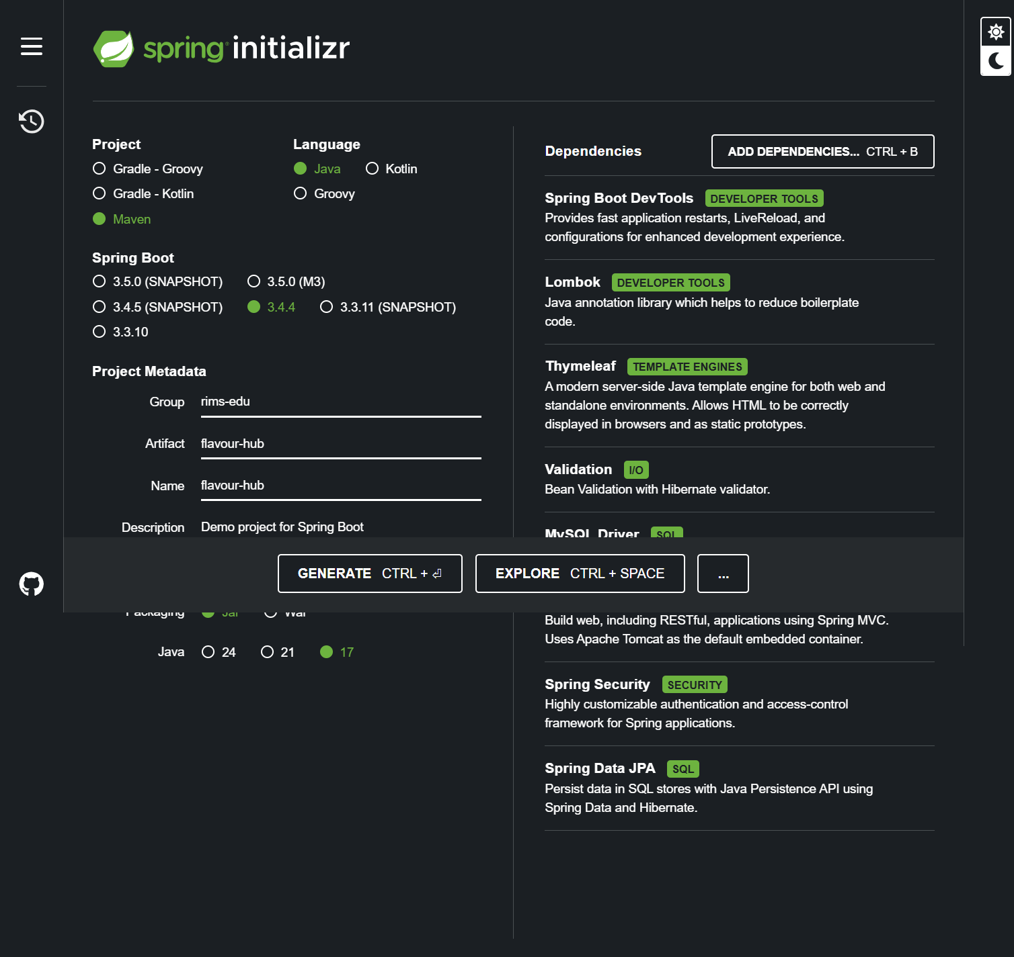

* **Database:**
  + MySQL Server : For managing and storing application data.
  + MySQL Workbench : For database administration and visualization.

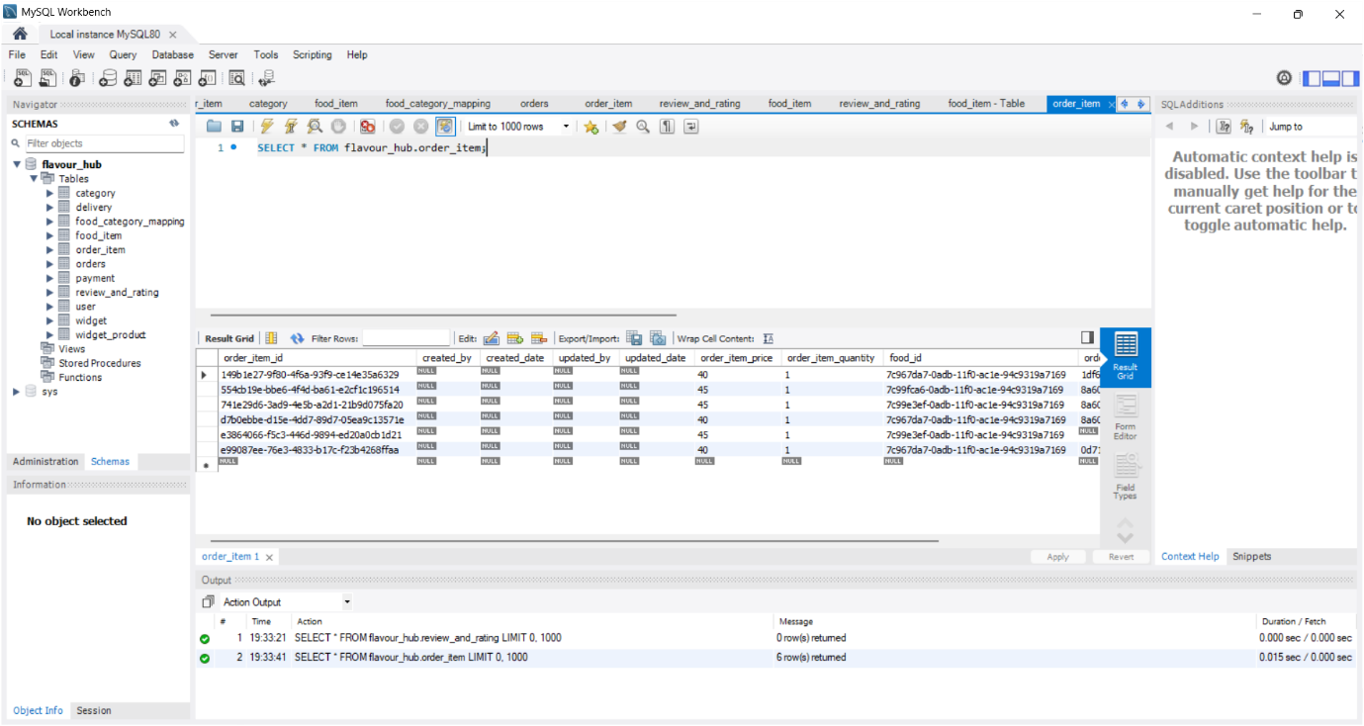

(Category table data)

* **Development Tools:**
  + IDE**:** Visual Studio Code (VS Code) or IntelliJ IDEA.
  + Build Tool**:** Maven :To manage dependencies and build the project.
  + Version Control**:** Git : For tracking changes and collaboratin

**2.4 : Hardware Requirement**

The following hardware specifications are recommended for developing and running the Flavour Hub application:

* For Development Environment:
  + Processor**:** Intel Core i5.
  + RAM**:** 8 GB for smoother multitasking.
  + Storage**:** SSD with 256 GB for faster build times.
  + Graphics**:** Integrated graphics (sufficient for development).
  + Network**:** Stable internet connection for accessing external dependencies and APIs.

**Chapter :3**

**System Design**

**3.1: Introduction**

The **system design** of Flavour Hub, a cloud kitchen e-commerce platform, defines the **architectural blueprint** of the application. It outlines how different components, such as the frontend, backend, and database, interact to deliver a seamless experience. The design process begins with a **conceptual overview,** highlighting the core actors and processes, followed by detailed **data flow diagrams (DFD)** to represent the movement of information between various modules. The **ER diagram** illustrates the relationships between key entities like users, products, orders, and payments. The **logical design** describes the data model, API endpoints, and business logic, while the **physical design** focuses on the technologies used, including **Spring Boot** for backend development, **MySQL** for data storage, and **HTML, CSS, and JavaScript** for the frontend. This chapter serves as a technical foundation, ensuring the system is scalable, secure, and efficient in managing customer orders, product catalogs, and payments.

**3.2:Conceptual Design**

The conceptual design focuses on the high-level representation of the system, defining its main components and their relationships without diving into technical details.

For Flavour Hub, the conceptual design includes:

* **Actors:**
  + Customers: Place orders, view products, and make payments.
  + Admins: Manage products, orders, and view reports.
* **Processes:**
  + Product Management**:** Admins add, update, and delete food items.
  + Order Management**:** Customers place orders, and admins track them.
  + Payment Process**:** Customers pay using integrated payment gateways.
* **Data Flow:**
  + Users interact with the frontend (HTML, CSS, JS).
  + Backend (Spring Boot) processes requests and communicates with the MySQL database.
  + Responses are sent back to the frontend.

**3.3 : Data Flow Diagram (DFD) of “FLAVOUR HUB Website”**

## **Context level DFD for Online food system**

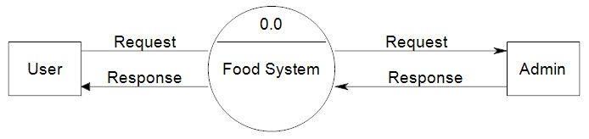

## **1st level DFD for User**

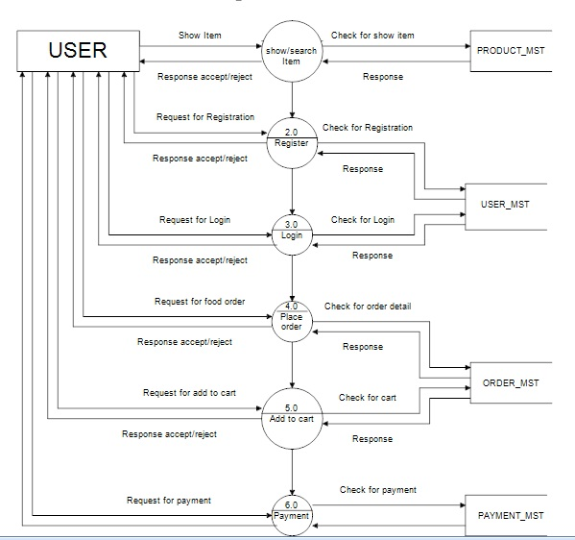

## **2nd level DFD for user**

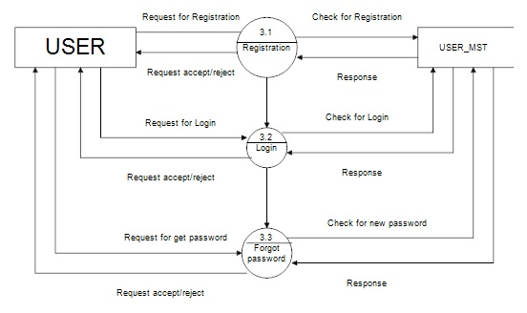

## **Admin side DFD for online food system**

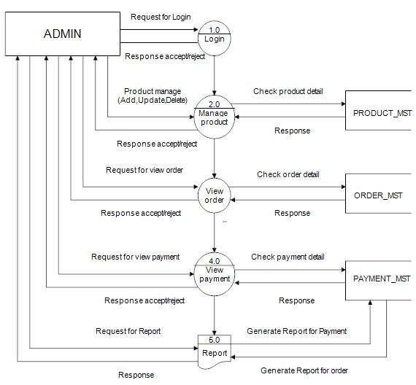

**3.4 : E-R Diagram**

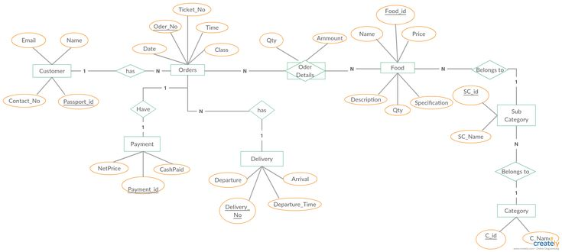

**3.5 : Logical Design**

The logical design defines the data model and application logic without considering the physical implementation. It focuses on:

* **Database Schema:**
  + Tables: User, Product, Category, Order, OrderItem, Payment.
  + Relationships: Primary and foreign key constraints.
* **Business Logic:**
  + Authentication**:**
    - Spring Security handles user authentication.
  + **Order Management:**
    - Customers place orders, and the backend handles order processing.
  + **Product Management:**
    - Admins manage food items through CRUD operations.
* **API Endpoints:**
  + GET /products → Retrieve product list.
  + POST /cart/add → Add items to the cart.
  + POST /order/place → Place an order.
  + GET /admin/orders → View all orders.

**3.6 : Physical Design**

The physical design details the actual implementation and technology stack used in your project. It specifies how the system is built and deployed.

* **Backend (Server-side)**
* Language**:** Java (Spring Boot)
* Framework**:** Spring Boot
* Server: Embedded Apache Tomcat
* RESTful APIs**:** For data exchange
* **Frontend (Client-side)**
* Languages**:** HTML, CSS, JavaScript
* Framework: Bootstrap for styling
* Templates:
  + home.html, customer.html, admin.order.html
  + Static templates for UI rendering
* **Database (Data Storage)**
* Database**:** MySQL
* Schema:
  + Tables: User, Product, Category, Order, OrderItem, Payment
* **JPA and Hibernate:**
  + Used for ORM (Object-Relational Mapping) to interact with the database.
* **Hosting & Deployment:**
* Local Deployment**:** Using Spring Boot’s embedded Tomcat server for local testing.
* Deployment Tools:
  + Build tool: Maven (pom.xml configuration).
  + IDE: Visual Studio Code.

**Chapter :4**

**System Analysis**

**4.1 : Purpose**

The purpose of the **Flavour Hub** project is to create a **cloud kitchen e-commerce platform** that offers customers a seamless food ordering experience. The system allows users to **browse products, place orders, and make payments** online, while providing admins with tools to **manage products, orders, and customer data** efficiently. The primary goal is to streamline the **food delivery process**, improve customer convenience, and enable the business to scale its operations through a user-friendly and secure platform.

**4.2 : Project Scope**

The scope of the Flavour Hub project defines its features, functionalities, andlimitations:

* **User Roles:**
  + Customers**:** Browse food items, place orders, and make payments.
  + Admins: Manage products, view orders, and handle customer data.
* **Core Features:**
  + Product Management: Admins can add, update, and remove food items.
  + Order Management**:** Customers can place and track orders.
  + Payment Gateway**:** Secure online payments.
  + Authentication**:** User registration and login with Spring Security.
* **Technological Scope:**
  + Backend: Spring Boot REST APIs with embedded Tomcat.
  + Database: MySQL for data storage.
  + Frontend: HTML, CSS, JavaScript, and Bootstrap.
* **Limitations:**
  + The system currently supports only one payment method.
  + It does not include real-time order tracking but provides status updates.

**4.3 : Existing System**

The existing system refers to traditional food delivery or manual order management methods that lack efficiency and automation.

* **Manual Ordering:**
  + Customers place orders over the phone or in person.
  + Inconsistent order tracking.
* **Limited Inventory Management:**
  + Manual stock management, prone to errors.
* **Payment Inconsistencies**:
  + Cash-based transactions lead to payment delays and errors.
* **Lack of Centralized Database:**
  + Customer information and order details are not stored centrally, making data retrieval slow and inefficient.

**4.4 : Proposed System**

The proposed system, Flavour Hub, is a fully automated cloud kitchenplatform that streamlines food ordering and delivery.

* **User-Friendly Interface:**
  + Customers can browse, search, and filter food items easily.
* **Efficient Order Management:**
  + Orders are processed through RESTful APIs, enabling faster and more accurate order management.
* **Secure Payments:**
  + Integration of payment gateways ensures secure and seamless transactions.
* **Centralized Database:**
  + MySQL stores customer, product, and order information securely.
* **Admin Panel:**
  + Admins can manage products, orders, and view customer details.
* **Authentication and Security**:
  + Spring Boot Security ensures only authenticated users can access the system.

**4.4 : System Description**

The system description provides a brief overview of how the FlavourHub platform functions.

* **Frontend:**
  + Built using HTML, CSS, and JavaScript, the frontend offers a user-friendly interface.
  + Customers can view products, add items to the cart, and place orders.
* **Backend:**
  + Developed using Spring Boot, the backend handles user authentication, order management, and product operations.
  + RESTful APIs facilitate data exchange between the frontend and backend.
* **Database:**
  + MySQL stores and manages the data, including product details, customer information, and order history.
* **Server:**
  + The application runs on Spring Boot’s embeddedTomcat server, handling HTTP requests.
* **Security:**
  + Spring Security ensures secure authentication andauthorization for both customers and admins.

**Chapter 5: Implementation Issues**

**5.1 HTML**

HTML forms the backbone of the Flavour Hub cloud kitchen website. The implementation challenges faced while working with HTML include:

* **Semantic Structuring:** Ensuring proper use of semantic elements for better SEO(Search Engine Optimization) and accessibility.
* **Responsive Design Issues:** Difficulty in achieving a consistent layout across different devices.
* **Cross-Browser Compatibility:** Variations in how browsers render HTML elements, leading to inconsistencies.
* **Form Validation Constraints:** Client-side validation sometimes fails to work efficiently, requiring additional JavaScript support.

**5.2 CSS**

CSS is used to style the Flavour Hub website and provide a visually appealing interface. Some challenges encountered include:

* **Flexbox and Grid Layout Adjustments:** Achieving a fully responsive design using CSS Grid and Flexbox required multiple iterations.
* **Styling Consistency Across Browsers:** Differences in how browsers interpret CSS properties, requiring extensive testing.
* **Managing Large Stylesheets:** As the project grew, maintaining and organizing CSS files became challenging, leading to the adoption of SCSS for better modularity.
* **Animations and Transitions:** Ensuring smooth animations without affecting page performance was a challenge.

**5.3 JavaScript**

JavaScript is used to handle interactive components of the Flavour Hub website. The primary challenges faced include:

* **DOM Manipulation Performance:** Frequent updates to the DOM affected performance, requiring optimization techniques like event delegation.
* **Asynchronous Operations:** Managing asynchronous data fetching from APIs without blocking UI updates.
* **Cross-Browser Issues:** Some JavaScript features were not supported across all browsers, necessitating polyfills.
* **Security Concerns:** Preventing XSS (Cross-Site Scripting) and CSRF (Cross-Site Request Forgery) attacks.

**5.4 Java**

Java is used in the backend of the Flavour Hub system. Some challenges faced in its implementation include:

* **Performance Optimization:** Handling multiple requests simultaneously without slowing down the server.
* **Memory Management:** Ensuring efficient garbage collection and preventing memory leaks.
* **Integration with Databases:** Managing connections efficiently to prevent bottlenecks in data retrieval.
* **Error Handling:** Implementing a robust exception-handling mechanism to avoid system crashes.

**5.5 Spring Boot**

Spring Boot is used to develop the backend of the Flavour Hub website. The key implementation issues encountered include:

* **Configuration Management:** Properly setting up properties files for different environments (development, testing, production).
* **Dependency Injection Issues:** Managing dependency injections efficiently without causing bean conflicts.
* **Security Configuration:** Setting up authentication and authorization mechanisms to prevent unauthorized access.
* **REST API Performance:** Optimizing RESTful APIs to handle multiple concurrent user requests efficiently.

**5.6 MySQL**

MySQL is used as the database for Flavour Hub. The implementation issues faced include:

* **Database Schema Design:** Structuring tables efficiently to handle complex queries and relationships.
* **Query Optimization:** Ensuring SQL queries run efficiently to prevent slow page loads.
* **Data Consistency Issues:** Handling transactions properly to prevent data inconsistencies.
* **Scaling Challenges:** Ensuring the database can handle increased traffic without performance degradation.

**Chapter 6.**

**User’s Screen and Coding**

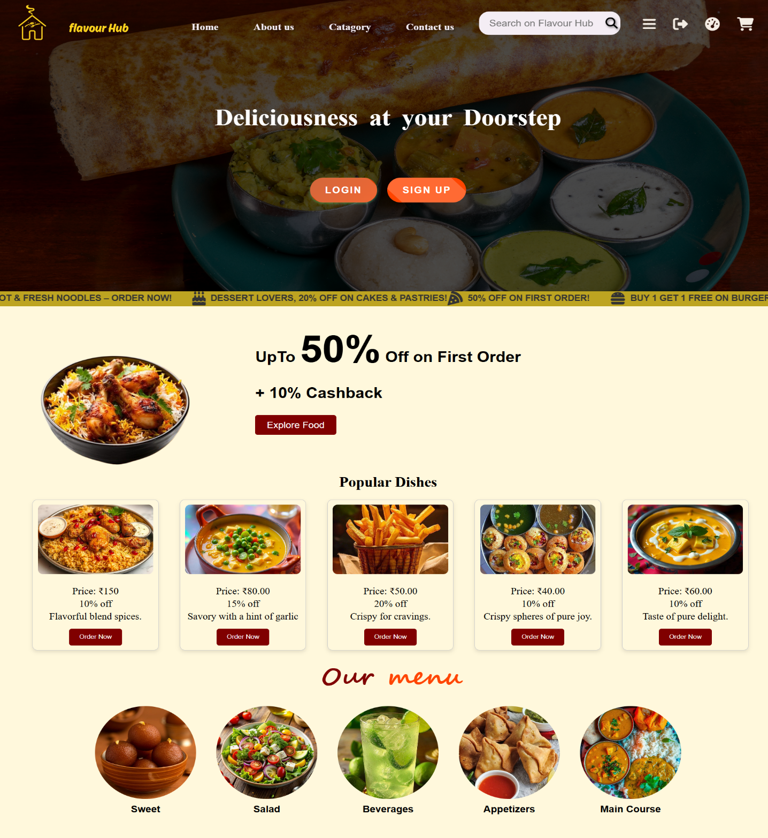

<!DOCTYPE html>

<html lang="en">

<head data-th-replace="~{customer/common :: head}">

</head>

<body>

    <link rel="stylesheet" href="/style/customer.home.css">

    <header data-th-replace="~{customer/common :: header}"></header>

    <!-- banner image section -->

    <div class="banner">

        <div class="banner-img">

            <div class="overlay">

                <div class="decription">

                    <h1>Deliciousness at your Doorstep</h1>

                </div>

                <div class="button-container">

                    <a href="/customer/login"><button class="login-btn" onclick="openLoginPage()">Login</button></a>

                    <a href="/customer/login"><button class="signup-btn" onclick="openLoginPage()">Sign Up</button></a>

                </div>

            </div>

        </div>

    </div>

    <!-- scrolling offer -->

    <div class="scroll-offer">

        <div class="scroll-text-wrapper">

            <!-- First batch of offers -->

            <div class="scroll-text">

                <span><i class="fas fa-pizza-slice"></i> 50% OFF on First Order!</span>

                <span><i class="fas fa-hamburger"></i> Buy 1 Get 1 Free on Burgers!</span>

                <span><i class="fas fa-sushi"></i> Flat 30% OFF on Pizzas!</span>

                <span><i class="fas fa-cocktail"></i> Free Drink on Orders Above $20!</span>

                <span><i class="fas fa-utensils"></i> Hot & Fresh Noodles – Order Now!</span>

                <span><i class="fas fa-birthday-cake"></i> Dessert Lovers, 20% OFF on Cakes & Pastries!</span>

            </div>

    <!-- offer section -->

    <div class="left-align-wrapper">

        <section class="">

            <div class="content grid">

                <div class="content-left">

                    <div class="info">

                        <h2>UpTo <span>50%</span> Off on First Order</h2>

                        <h2>+ 10% Cashback</h2>

                        <button>Explore Food</button>

                    </div>

                    <div class="img-sec">

                        <img src="/images/biriyani-bg.png" alt="">

                    </div>

                </div>

            </div>

        </section>

    </div>

    <!--popular dish-->

    <div class="popular-dishes">

        <h2>Popular Dishes</h2>

        <div class="sub-popular-dishes">

            <div class="dish">

                <div class="image-container">

                    <img src="/images/biriyani3.jpg" alt="">

                </div>

    <!--menu-->

    <section class="catagory" id="catagory-menu">

        <div class="menu" id="menu">

            <h1>Our <span>menu</span></h1>

            <div class="food-gallery">

                <div class="food-container" data-th-each="category : ${categories}">

                    <a data-th-href="|/customer/category/plp?category=${category.categoryId}|">

                        <div class="food-image">

                            <img data-th-src="|/category/image/${category.categoryId}|" alt="samosha">

                        </div>

                    </a>

                    <div class="food-name" data-th-text="${category.categoryName}"></div>

                </div>

            </div>

        </div>   </section>

Product listing page

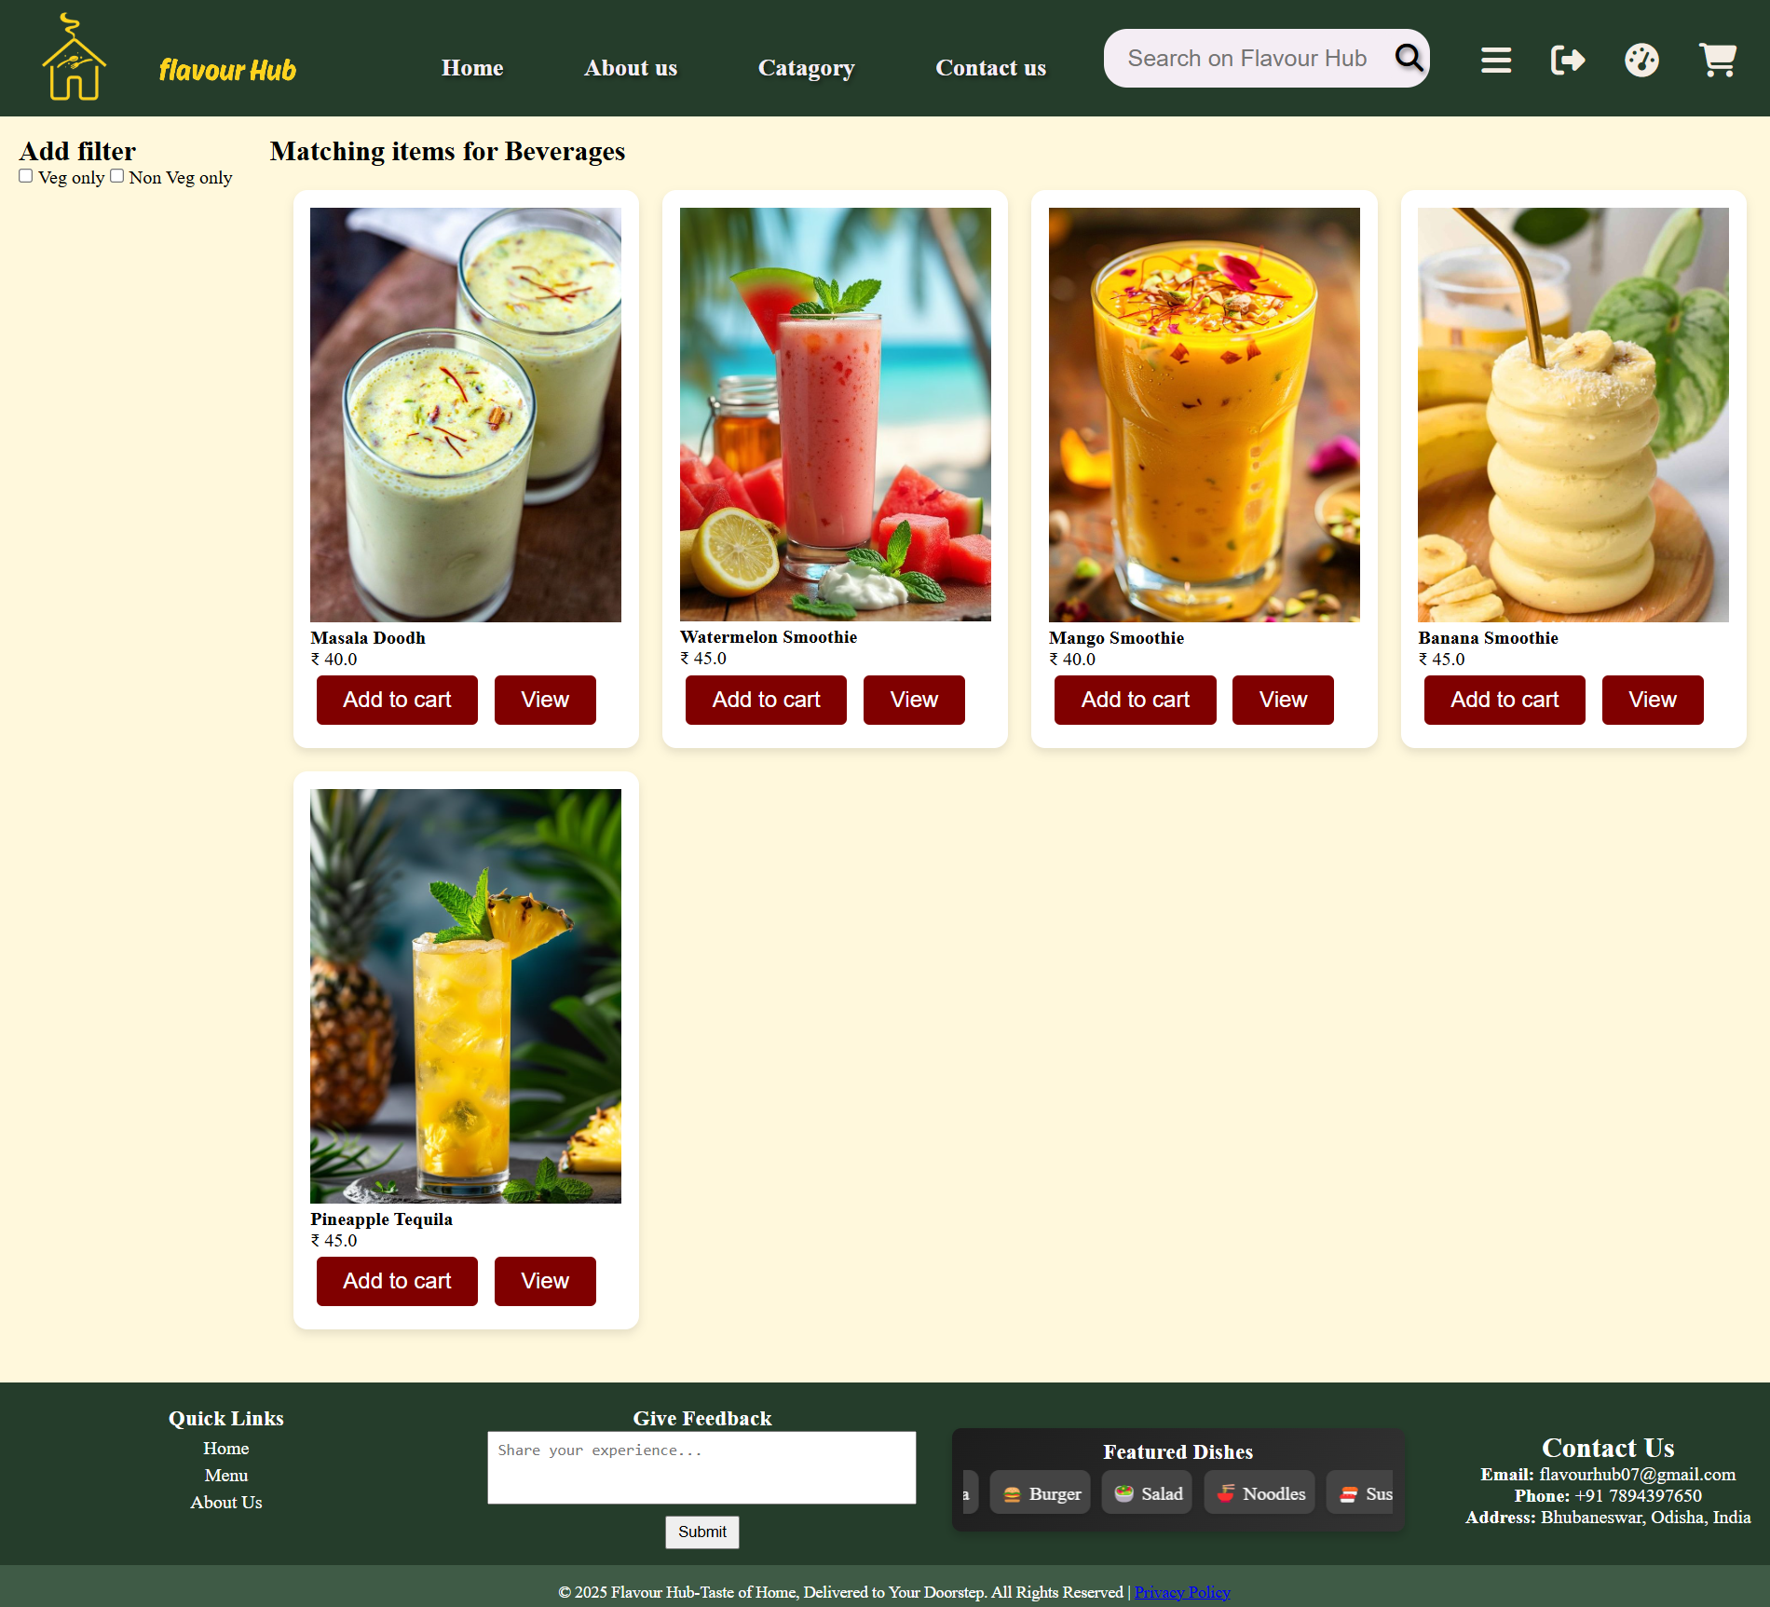

        <div class="products-section" data-th-if="${param.category != null}">

            <h2 data-th-text="|Matching items for ${category.categoryName}|"></h2>

            <div class="product-container">

                <article class="product" data-th-each="item : ${category.foodItems}">

                    <a data-th-href="|/customer/food_item/pdp?food_item=${item.foodId}|">

                        <div class="img-container">

                            <img data-th-src="|/foodItem/image/${item.foodId}|" alt="">

                        </div>

                        <div class="product-title">

                            <h4 data-th-text="${item.foodName}"></h4>

                            <p data-th-text="|&#8377; ${item.price}|"></p>

                        </div>

                        <div class="product-action">

                            <button> <a data-th-href="|/customer/cart/add?item=${item.foodId}|">Add to cart</a></button>

                            <button> <a data-th-href="|/customer/food_item/pdp?food_item=${item.foodId}|">View</a>

                            </button>

                        </div>

                    </a>

                </article>

   <div data-th-if="${#lists.size(category.foodItems) == 0}">

                    <h1>No Item Available</h1>

                </div>

            </div>

        </div>

        <div class="products-section" data-th-if="${param.search != null}">

            <h2 data-th-text="|Matching items for ${param.search}|"></h2>

            <div class="product-container">

                <article class="product" data-th-each="item : ${foodItems}">

                    <a data-th-href="|/customer/food_item/pdp?food_item=${item.foodId}|" style="all: unset;">

                        <div class="img-container">

                            <img data-th-src="|/foodItem/image/${item.foodId}|" alt="">

                        </div>

                        <div class="product-title">

                            <h4 data-th-text="${item.foodName}"></h4>

                            <p data-th-text="|&#8377; ${item.price}|"></p>

                        </div>

                        <div class="product-action">

                            <a data-th-href="|/customer/cart/add?item=${item.foodId}|">Add to cart</a>

                            <button>View</button>

                        </div>

                    </a>

                </article>

                <div data-th-if="${#lists.size(foodItems) == 0}">

                    <h1>No Item Available</h1>

                </div>

            </div>

        </div>

    </main>

**Product Description page**

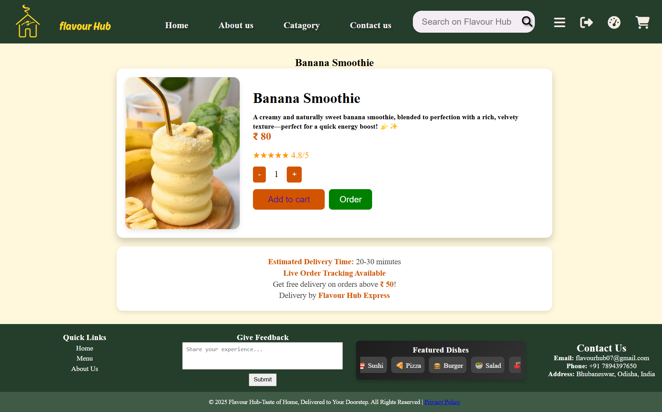

 <div class="pdp-section">

        <h2 data-th-text="|${food_item.foodName}|"></h2>

        <div class="container">

            <article class="product">

                <img data-th-src="|/foodItem/image/${food_item.foodId}|" alt="Delicious Dish" class="product-image">

                <div class="product-details">

                    <div class="product-title">

                        <h3 data-th-text="${food_item.foodName}"></h3>

                    </div>

                    <p class="product-description">

                    <h4 data-th-text="${food_item.foodDescription}"></h4>

                    </p>

                    <p class="product-price">&#8377; 80</p>

                    <div class="ratings">★★★★★ 4.8/5</div>

                    <div class="quantity-selector">

                        <button onclick="changeQuantity(-1)">-</button>

                        <span id="quantity">1</span>

                        <button onclick="changeQuantity(1)">+</button>

                    </div>

                    <div class="btn">

                        <button class="add-to-cart">

                            <a data-th-href="|/customer/cart?item=${food_item.foodId}|">Add to cart</a></button>

                        <button class="order" onclick="order()">Order</button>

                    </div>

</div>

            </article>

        </div>

**User Login**

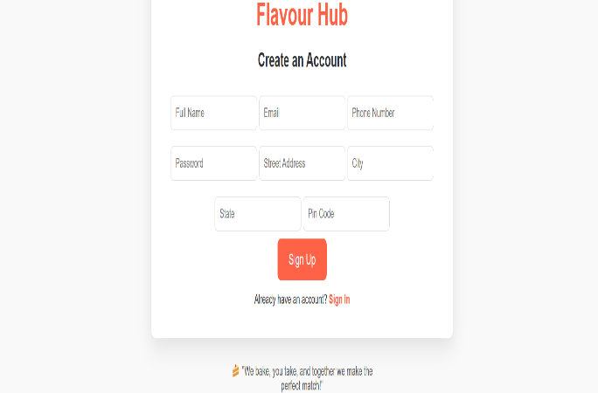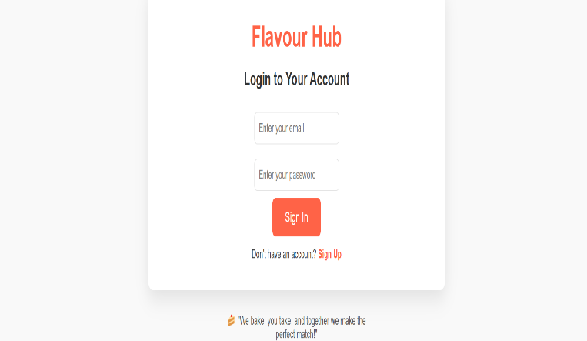

Login code

 <div id="loginForm">

            <h2>Login to Your Account</h2>

            <form class="form" method="post" action="/customer/login">

                <input type="text" name="username" id="loginEmail" placeholder="Enter your email" required>

                <input type="password" name="password" id="loginPassword" placeholder="Enter your password" required>

                <input type="hidden" name="_csrf" data-th-value="${_csrf.token}">

                <button type="submit">Sign In</button>

            </form>

            <p class="toggle-text">Don't have an account? <a href="#" onclick="toggleForms()">Sign Up</a></p>

        </div>

Signup

 <div id="signupForm" class="hidden">

            <h2>Create an Account</h2>

            <form class="form" method="post" action="/customer/sign-up">

                <div class="name">

                    <input type="text" id="signupName" name="userName" placeholder="Full Name" required>

                    <input type="email" id="signupEmail" name="userEmail" placeholder="Email" required>

                    <input type="tel" id="userPhone" name="userPhone" placeholder="Phone Number" required>

                    <input type="password" id="signupPassword" name="userPassword" placeholder="Password" required>

                    <input type="text" id="street" name="userAddress" placeholder="Street Address" required>

                    <input type="text" id="city" placeholder="City" required>

                    <input type="text" id="state" placeholder="State" required>

                    <input type="text" id="zip" placeholder="Pin Code" required>

                </div>

                <input type="hidden" name="_csrf" data-th-value="${_csrf.token}">

                <button type="submit">Sign Up</button> </form>

            <p class="toggle-text">Already have an account? <a href="#" onclick="toggleForms()">Sign In</a></p>

        </div>

    </div>

**Product Controller Code**

package edu.rims.flavour_hub.controller;

import java.io.FileInputStream;

import java.io.IOException;

import java.util.List;

import org.springframework.beans.factory.annotation.Autowired;

import org.springframework.stereotype.Controller;

import org.springframework.ui.Model;

import org.springframework.web.bind.annotation.GetMapping;

import org.springframework.web.bind.annotation.PathVariable;

import org.springframework.web.bind.annotation.RequestParam;

import org.springframework.web.bind.annotation.ResponseBody;

import edu.rims.flavour_hub.constant.FoodStatus;

import edu.rims.flavour_hub.entity.Category;

import edu.rims.flavour_hub.entity.FoodItem;

import edu.rims.flavour_hub.repository.CategoryRepository;

import edu.rims.flavour_hub.repository.Food_itemRepository;

@Controller

public class ProductController {

    @Autowired

    private CategoryRepository categoryRepository;

    @Autowired

    private Food_itemRepository food_itemRepository;

    @GetMapping("/customer/category/plp")

    String getProductByCategoryId(@RequestParam("category") String categoryId, Model model) {

        Category category = categoryRepository.findCategoryByIdAndFoodItemStatus(categoryId, FoodStatus.AVAILABLE)

                .orElseThrow();

        model.addAttribute("category", category);

        return "customer/plp";

    }

    @GetMapping("/customer/food_item/pdp")

    String getProductByFoodId(@RequestParam("food_item") String foodId, Model model) {

        FoodItem food_item = food_itemRepository.findById(foodId).orElseThrow();

        model.addAttribute("food_item", food_item);

        return "customer/pdp";

    }

    @GetMapping("/product/search")

    String searchProduct(@RequestParam("search") String foodItemName, Model model) {

        List<FoodItem> foodItems = food_itemRepository.findByFoodNameContainingIgnoreCaseAndFoodItemStatus(foodItemName,

                FoodStatus.AVAILABLE);

        model.addAttribute("foodItems", foodItems);

        return "customer/plp";

    }

    @GetMapping(value = "/category/image/{categoryId}", produces = { "image/jpg", "image/png", "image/jpeg" })

    @ResponseBody

    byte[] getCategoryImage(@PathVariable String categoryId) throws IOException {

        Category category = categoryRepository.findById(categoryId).orElseThrow();

        String categoryImageUrl = category.getCategoryImageUrl();

        if (categoryImageUrl != null && categoryImageUrl.startsWith("http")) {

            return null;

        }

        FileInputStream fis = new FileInputStream(categoryImageUrl);

        return fis.readAllBytes();

    }

    @GetMapping(value = "/foodItem/image/{foodItemId}", produces = { "image/jpg", "image/png", "image/jpeg" })

    @ResponseBody

    byte[] getfoodItemImage(@PathVariable String foodItemId) throws IOException {

        FoodItem foodItem = food_itemRepository.findById(foodItemId).orElseThrow();

        String foodItemImageUrl = foodItem.getFoodItemImageUrl();

        if (foodItemImageUrl != null && foodItemImageUrl.startsWith("http")) {

            return null;

        }

        FileInputStream fis = new FileInputStream(foodItemImageUrl);

        return fis.readAllBytes();

    }}

Cart page

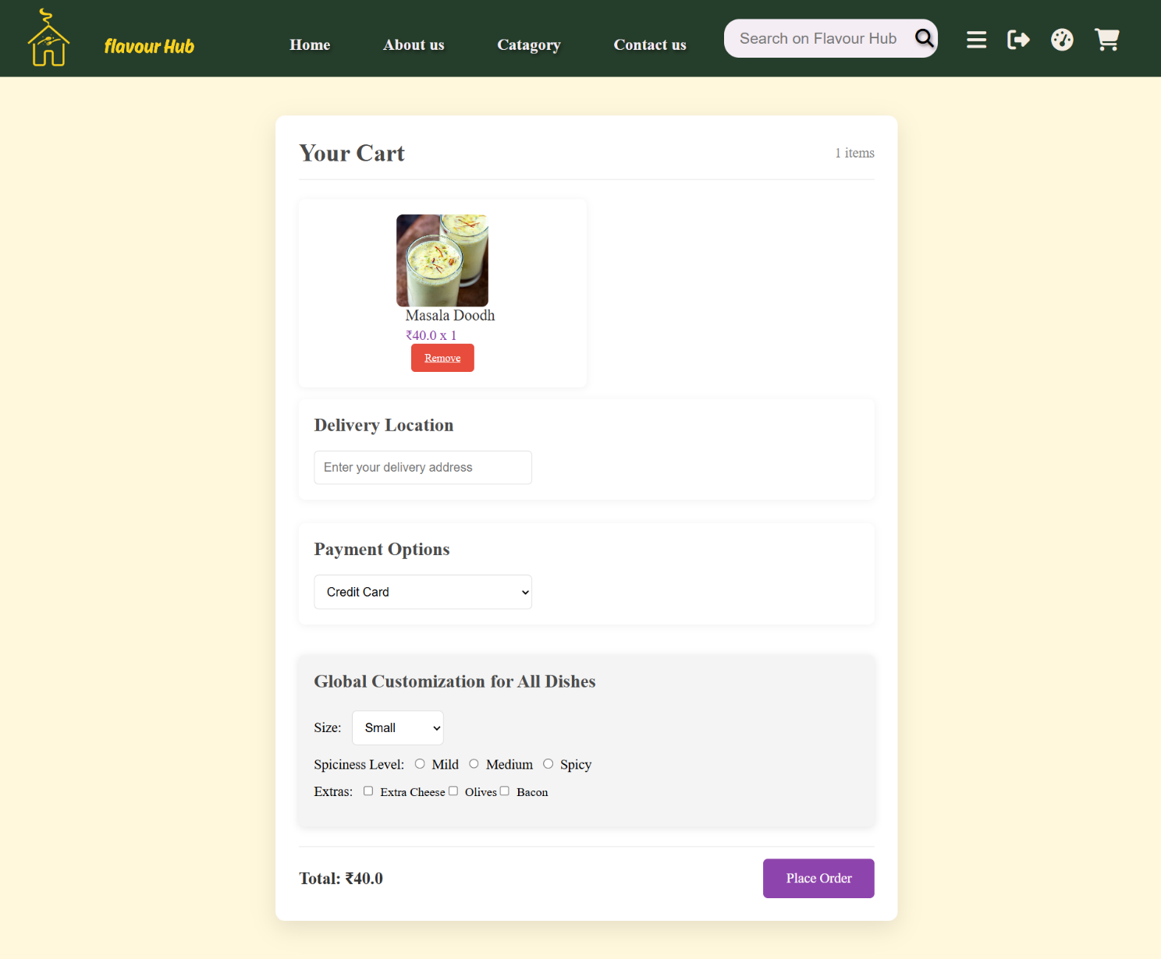

**Chapter 7.**

**Admin Screen and Coding**

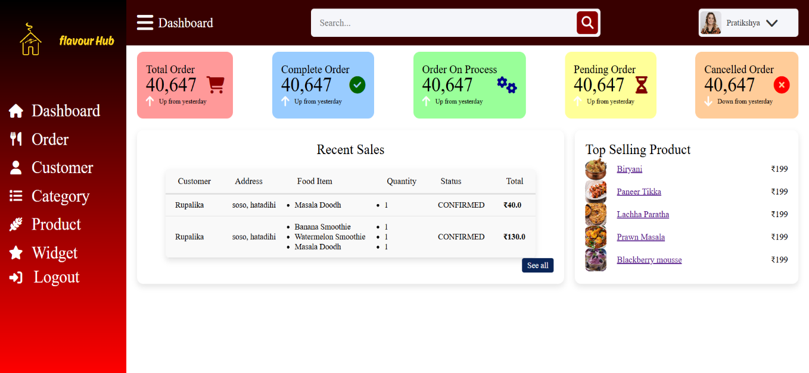

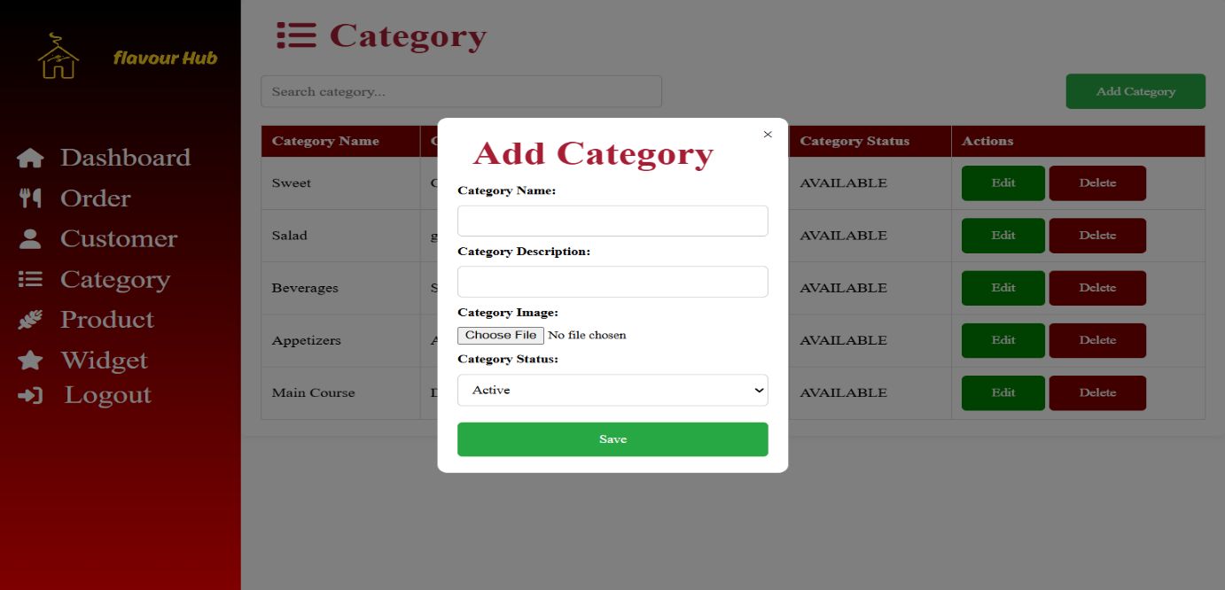

Admin Dashboard

 <div class="sales-boxes">

                <div class="recent-sale-box">

                    <div class="title">Recent Sales</div>

                    <div class="sales-details">

                        <table>

                            <thead>

                                <tr> <th>Customer</th>

                                    <th>Address</th>

                                    <th>Food Item</th>

                                    <th>Quantity</th>

                                    <th>Status</th>

                                    <th>Total</th>

                                </tr>

                            </thead>

                            <tbody>

                                <tr data-th-each="order : ${recentOrders}">

                                    <td data-th-text="${order.user.userName}"></td>

                                    <td data-th-text="${order.user.userAddress}"></td>

                                    <td>

                                       <ul>

                                            <li data-th-each="item : ${order.orderItems}">

                                                <span data-th-text="${item.foodItem.foodName}"></span>

                                            </li>

                                        </ul>

                                    </td>

                                    <td>

                                        <ul>

                                            <li data-th-each="item : ${order.orderItems}">

                                                <span data-th-text="${item.orderItemQuantity}"></span>

                                            </li>

                                        </ul>

                                    </td>

                                    <td>

                                        <p class="status"

                                            data-th-class="'status ' + ${order.orderStatus.name().toLowerCase()}">

                                        </p>

                                        <span data-th-text="${order.orderStatus}"></span>

                                    </td>

                                    <td><strong data-th-text="'₹' + ${order.totalPrice}"></strong></td>

                                </tr>

                            </tbody>

                        </table>

                    </div>

                    <div class="button">

                        <a href="/admin/order">See all</a>

                    </div>

                </div>

**Chapter 8:**

**Testing**

**8.1 Software Testing Life Cycle (STLC)**

The Software Testing Life Cycle (STLC) is a structured process followed during the testing phase of the Flavour Hub cloud kitchen website. It includes the following stages:

* **Requirement Analysis:** Understanding functional and non-functional requirements to determine test objectives.
* **Test Planning:** Creating a strategy for testing, including scope, resources, schedule, and risks.
* **Test Case Development:** Designing and documenting test cases based on requirements.
* **Environment Setup:** Preparing the necessary hardware, software, and configurations for testing.
* **Test Execution:** Running test cases and identifying defects.
* **Test Closure:** Evaluating the testing process, documenting learnings, and finalizing reports.

**8.2 Test Plan Creation**

A test plan is developed to define the testing strategy for Flavour Hub. Key elements include:

* **Test Objectives:** Ensuring the website is fully functional, secure, and user-friendly.
* **Scope of Testing:** Covering functional, performance, security, and usability testing.
* **Test Deliverables:** Test cases, reports, defect logs, and final test summary.
* **Testing Tools:** Identifying tools like Selenium, JUnit, or Postman for automation and API testing.
* **Roles and Responsibilities:** Assigning team members to execute test cases and report issues.
* **Risk Analysis:** Identifying potential risks and mitigation strategies.

**8.3 Environment Setup**

The testing environment for Flavour Hub is configured to simulate real-world conditions. This includes:

* **Server Configuration:** Setting up development, testing, and production servers.
* **Database Setup:** Preparing a test database with sample data to validate CRUD operations.
* **Network & Security Configurations:** Ensuring firewalls and access controls are in place.
* **Browser & Device Compatibility:** Testing across multiple browsers (Chrome, Firefox, Edge) and devices (mobile, tablet, desktop).

**8.4 Defect Logging**

Defect logging ensures that issues found during testing are documented and tracked for resolution. The process includes:

* **Identifying Defects:** Noting issues related to UI, functionality, performance, and security.
* **Logging in a Bug Tracking Tool:** Using Jira, Bugzilla, or similar tools to track defects.
* **Prioritizing & Assigning Defects:** Categorizing defects based on severity (Critical, Major, Minor) and assigning them to developers.
* **Re-Testing & Verification:** Ensuring fixes are applied and validated.

**8.5 Test Cycle Closure**

The test cycle closure marks the completion of testing for Flavour Hub. It involves:

* **Final Test Report:** Summarizing test results, defect trends, and overall software quality.
* **Lessons Learned:** Documenting insights for improving future testing cycles.
* **Sign-Off:** Obtaining approval from stakeholders to proceed with deployment.
* **Post-Production Monitoring:** Ensuring a smooth transition from testing to live deployment.

**Conclusion**

A structured testing approach ensures the Flavour Hub website meets high-quality standards, providing a seamless user experience. Each phase of testing plays a vital role in identifying and resolving issues before deployment.

**Advantages and Limitations of Flavour Hub**

**Advantages**

**1. Convenience for Customers**

* Allows users to order food online from the comfort of their homes.
* Provides real-time menu updates and availability.

**2. Operational Efficiency**

* Reduces dependency on physical restaurants, lowering infrastructure costs.
* Streamlined order management through automated processes.

**3. Scalability**

* Can expand to multiple locations without requiring significant additional investment.
* Easy to integrate with third-party delivery services.

**4. Enhanced Customer Engagement**

* Personalized recommendations based on past orders.
* Loyalty programs and discounts to retain customers.

**5. Data-Driven Insights**

* Analytics on customer preferences, peak ordering times, and popular dishes.
* Helps in inventory and resource management.

**6. Cost-Effective Marketing**

* Digital marketing through social media, email campaigns, and app notifications.
* Lower advertising costs compared to traditional restaurant marketing.

**7. Seamless Payment Options**

* Supports multiple payment gateways, including credit/debit cards, UPI, and digital wallets.
* Reduces cash handling and improves transaction security.

**Limitations**

**1. Dependence on Internet & Technology**

* Requires stable internet connectivity for customers and staff.
* Technical glitches or server downtime can impact order processing.

**2. Logistics and Delivery Challenges**

* Delays due to traffic, weather, or delivery partner availability.
* Maintaining food quality during transit can be a challenge.

**3. High Competition**

* Competing with established food delivery platforms like Swiggy and Zomato.
* Requires aggressive marketing and promotions to attract customers.

**4. Initial Development Costs**

* Investment required for website and app development.
* Ongoing maintenance costs for software updates and security measures.

**5. Customer Trust & Retention**

* Gaining customer trust can take time, especially for new businesses.
* Negative reviews or poor service can impact brand reputation.

**6. Regulatory and Compliance Issues**

* Adhering to food safety regulations and licensing requirements.
* Managing taxation and legal compliances related to online transactions.

**7. Limited Personal Interaction**

* Lack of face-to-face customer service compared to traditional restaurants.
* Difficult to build strong customer relationships without physical engagement.

**Future Scope of Flavour Hub**

**1. Expansion to Multiple Locations**

* Scaling the cloud kitchen model to different cities and regions.
* Partnering with local food businesses for broader market reach.

**2. Mobile App Development**

* Launching a dedicated mobile app for a seamless ordering experience.
* Integration of push notifications for personalized offers and order updates.

**3. AI-Powered Recommendations**

* Implementing machine learning algorithms to suggest dishes based on user preferences.
* AI-driven chatbots for instant customer support and order assistance.

**4. Integration with Smart Kitchens**

* Automating food preparation using IoT-enabled kitchen equipment.
* Real-time monitoring of ingredient stock levels and automatic reordering.

**5. Enhanced Delivery System**

* Developing an in-house delivery fleet for faster and more reliable service.
* Real-time order tracking with estimated delivery times for customers.

**6. Subscription-Based Meal Plans**

* Offering customized meal subscription plans for daily or weekly deliveries.
* Personalized diet-based options such as keto, vegan, or high-protein meals.

**7. Sustainability Initiatives**

* Using eco-friendly packaging to reduce environmental impact.
* Partnering with local farms for fresh and organic ingredients.

**8. Collaboration with Corporate & Events**

* Providing catering services for offices, conferences, and private events.
* Partnering with co-working spaces for daily meal deliveries.

**9. Integration with Virtual Reality (VR) & Augmented Reality (AR)**

* Offering a virtual kitchen tour for customers to see hygiene standards.
* AR-based menu exploration for an interactive ordering experience.

**10. Loyalty & Referral Programs**

* Introducing a reward system to encourage repeat orders.
* Referral programs for customers to invite friends and earn discounts.

**Conclusion**

The **Flavour Hub** cloud kitchen project is a modern solution designed to revolutionize the food delivery industry. By leveraging technology, streamlined operations, and data-driven insights, the platform provides a seamless experience for customers while ensuring efficient kitchen management.

Throughout the development process, various challenges were addressed, including implementation issues related to frontend and backend technologies, database management, and security measures. Rigorous testing was conducted to enhance the platform’s stability, usability, and performance.

The project offers several advantages, such as cost efficiency, scalability, enhanced customer engagement, and optimized delivery services. However, challenges like high competition, logistics management, and dependency on technology must be continuously improved for long-term success.Looking ahead, **Flavour Hub** has significant growth potential, with future enhancements such as AI-driven recommendations, in-house delivery management, sustainability initiatives, and subscription-based meal plans. Expanding into new markets and integrating emerging technologies will further strengthen its position in the food-tech industry.

In conclusion, **Flavour Hub** serves as a promising digital platform that meets modern consumer demands while offering a scalable and sustainable business model. With continuous innovation and customer-centric improvements, it can evolve into a leading cloud kitchen solution in the food industry.

**Reference**

* Geeks for geeks-<https://www.geeksforgeeks.org/introduction-to-spring-boot/>
* Ghost kitchen - <https://cloudkitchens.com/blog/ultimate-guide-to-ghost-kitchens/>
* Baeldung-<https://cloudkitchens.com/blog/ultimate-guide-to-ghost-kitchens/>
* font awesome -<link rel="stylesheet" href="<https://cdnjs.cloudflare.com/ajax/libs/font-awesome/6.7.2/css/all.min.css> " integrity="sha512-Evv84Mr4kqVGRNSgIGL/F/aIDqQb7xQ2vcrdIwxfjThSH8CSR7PBEakCr51Ck+w+/U6swU2Im1vVX0SVk9ABhg==" crossorigin="anonymous" referrerpolicy="no-referrer" />
* Uber Eats -<https://www.ubereats.com/?ps=1>
* MySql- <https://dev.mysql.com/doc/workbench/en/>
* Eatance App- <https://eatanceapp.com/>
* Chatgpt - <https://chatgpt.com/c/67dc205a-f7f8-800b-aebe-1544680f9dab>
* Google
* Zomato-<https://www.zomato.com/who-we-are>
* Spring-<https://spring.io/projects/spring-authorization-server>